Username: Create your Forum Name (Handle) that is 3 to 15 characters long.
Email: Enter your email. This will be used to verify you are the person really wanting to login.
Check that you are not a robot
Click on the box to give us permission to email you the confirmation with a link to set up your password.
Click on the Register Button at the bottom of the section.
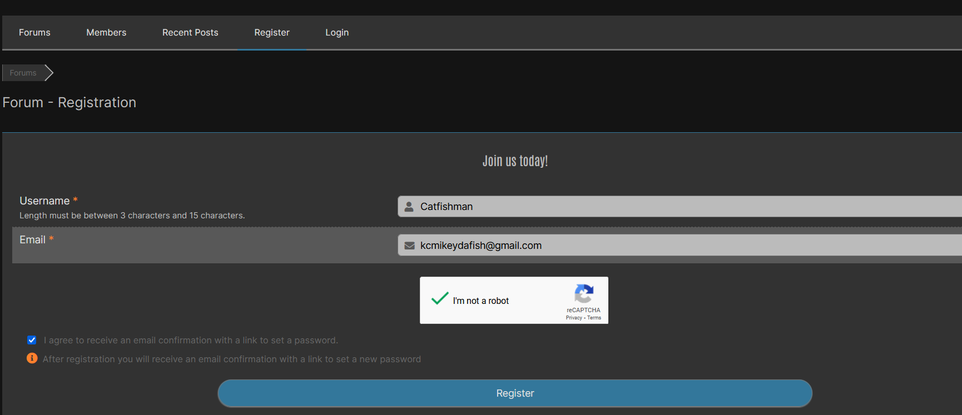

Note: there is also a method to login via your Facebook account. Then you only have one login and password to remember!

The KCFishClub will send you an email that is similar to below. Just click on the underlined link.
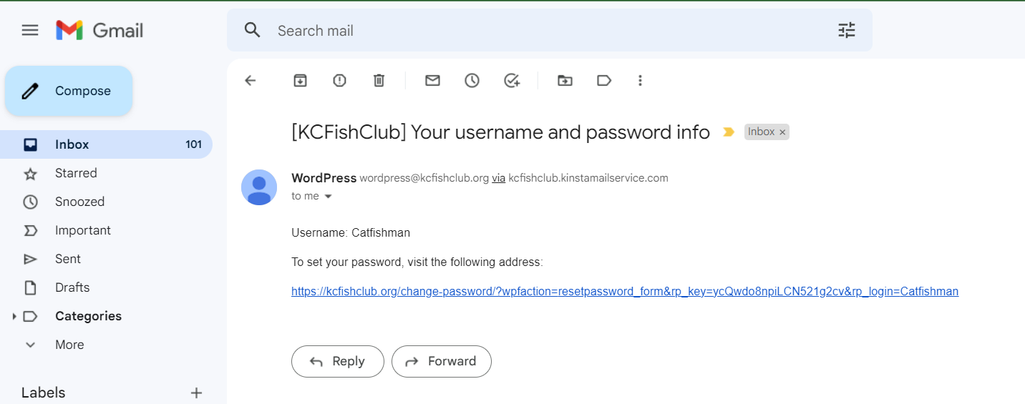
Now just set up a password. If you forget it later, a similar process will allow you to recover it!
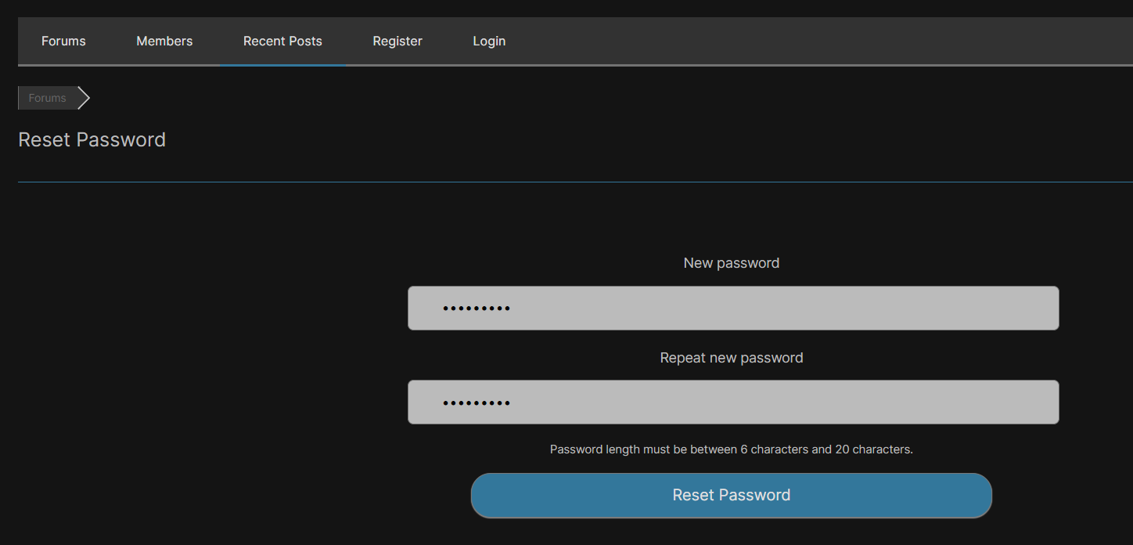

Now you can log in on the forum!
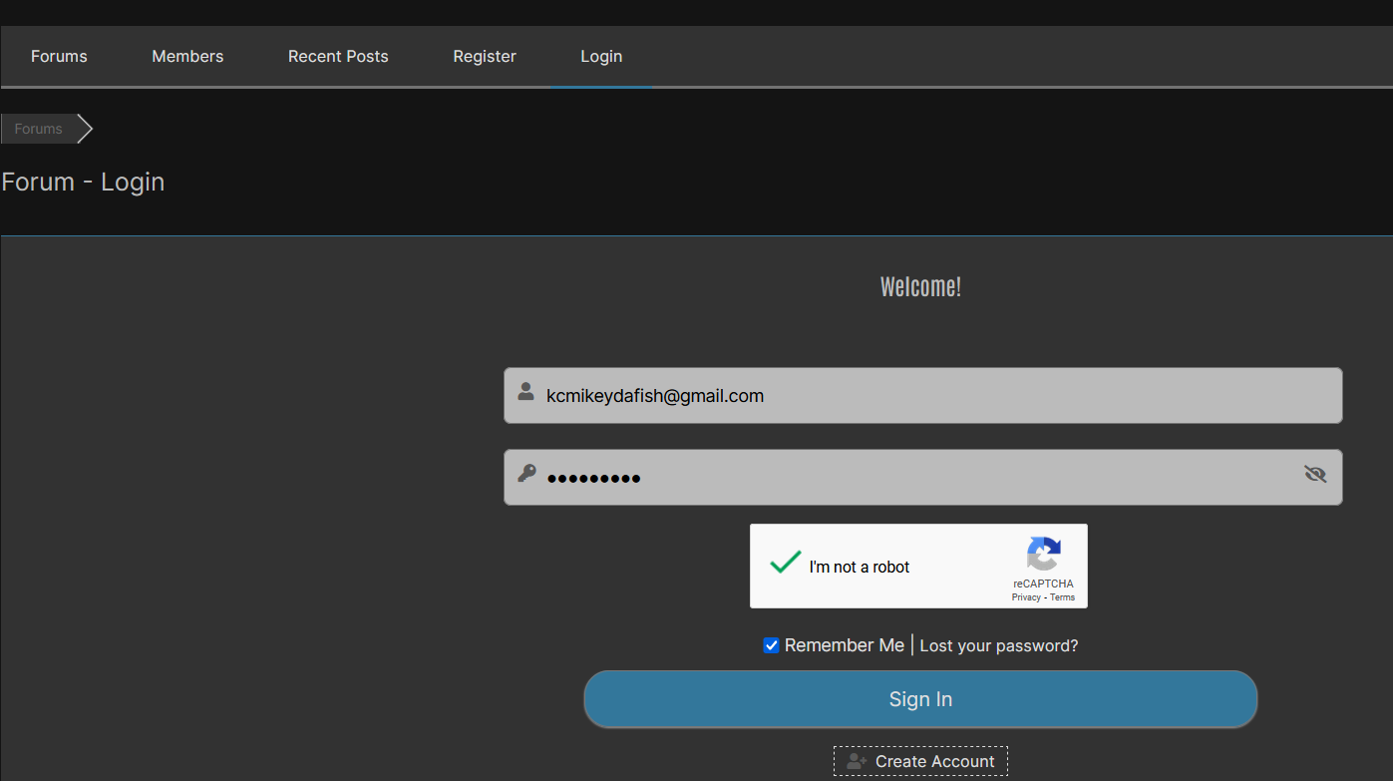
Enter User Name, Password, check that you are still not a robot and select Remember me if you want this prefilled out next time and you are off to the races!

